STARAGILE Java Application Development and Deployment Assignment

1. **Install Java 8 and the Latest Version of Eclipse:**
   * Download and install Java 8 from the official Oracle website

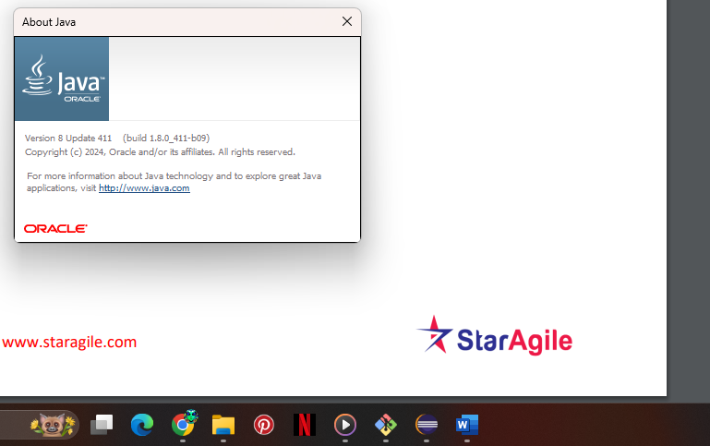

* + Download and install the latest version of Eclipse IDE for Java EE developers from the official Eclipse website.

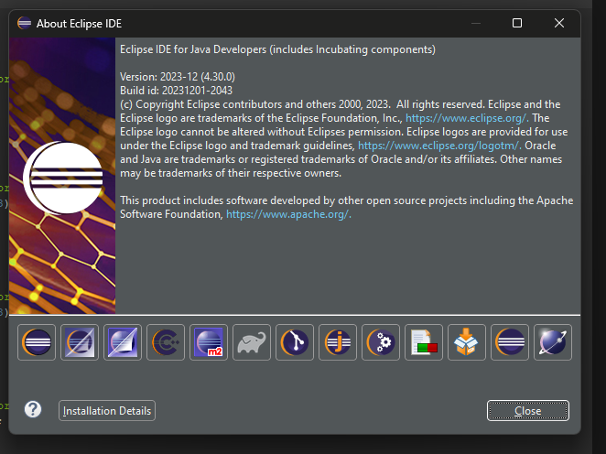

1. **Create a Java Dynamic Web Project:**
   * Open Eclipse IDE.
   * Go to "File" > "New" > "Dynamic Web Project".
   * Enter a project name, for example, "OnlineStore".
   * Choose "Target Runtime" as Apache Tomcat (if available).

Click "Next" and then "Finish".

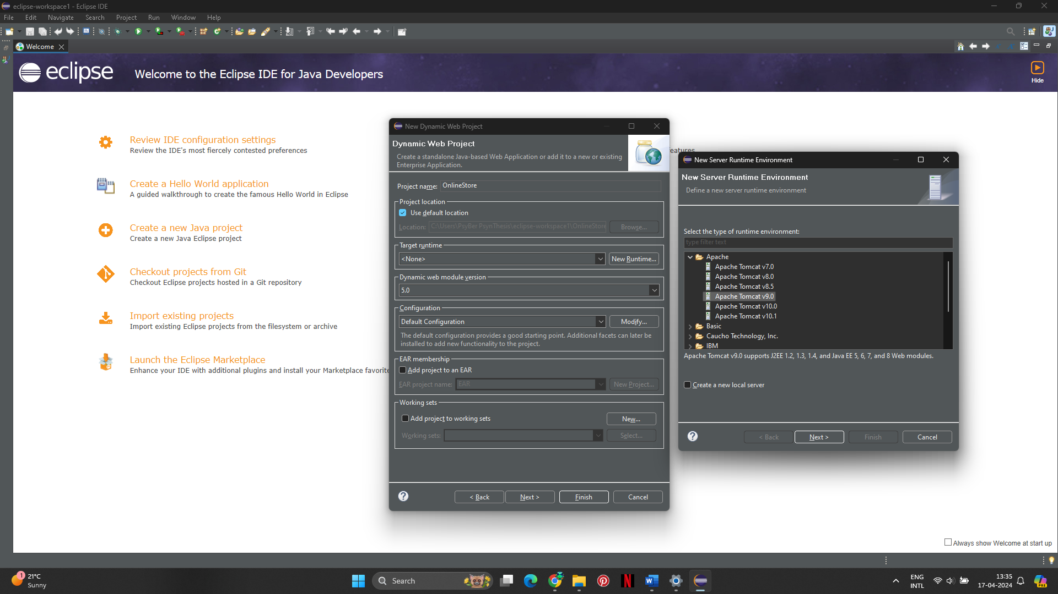

1. **Create an Index.html File:**

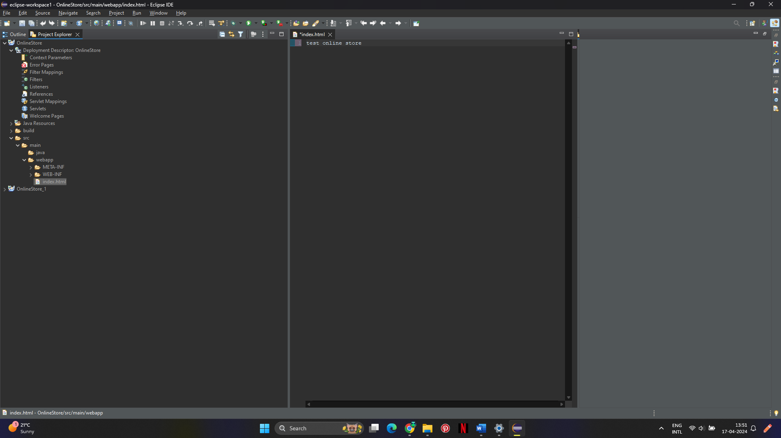

1. **Install the Tomcat 9 Server:**

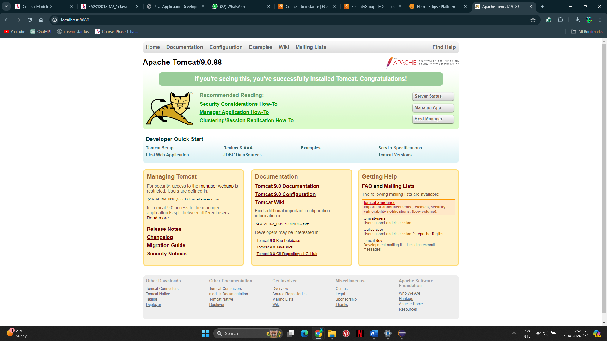

1. **Deploy the Application to the Tomcat 9 Server:**
   * In the properties window, go to "Targeted Runtimes" and select the Tomcat 9 server runtime.

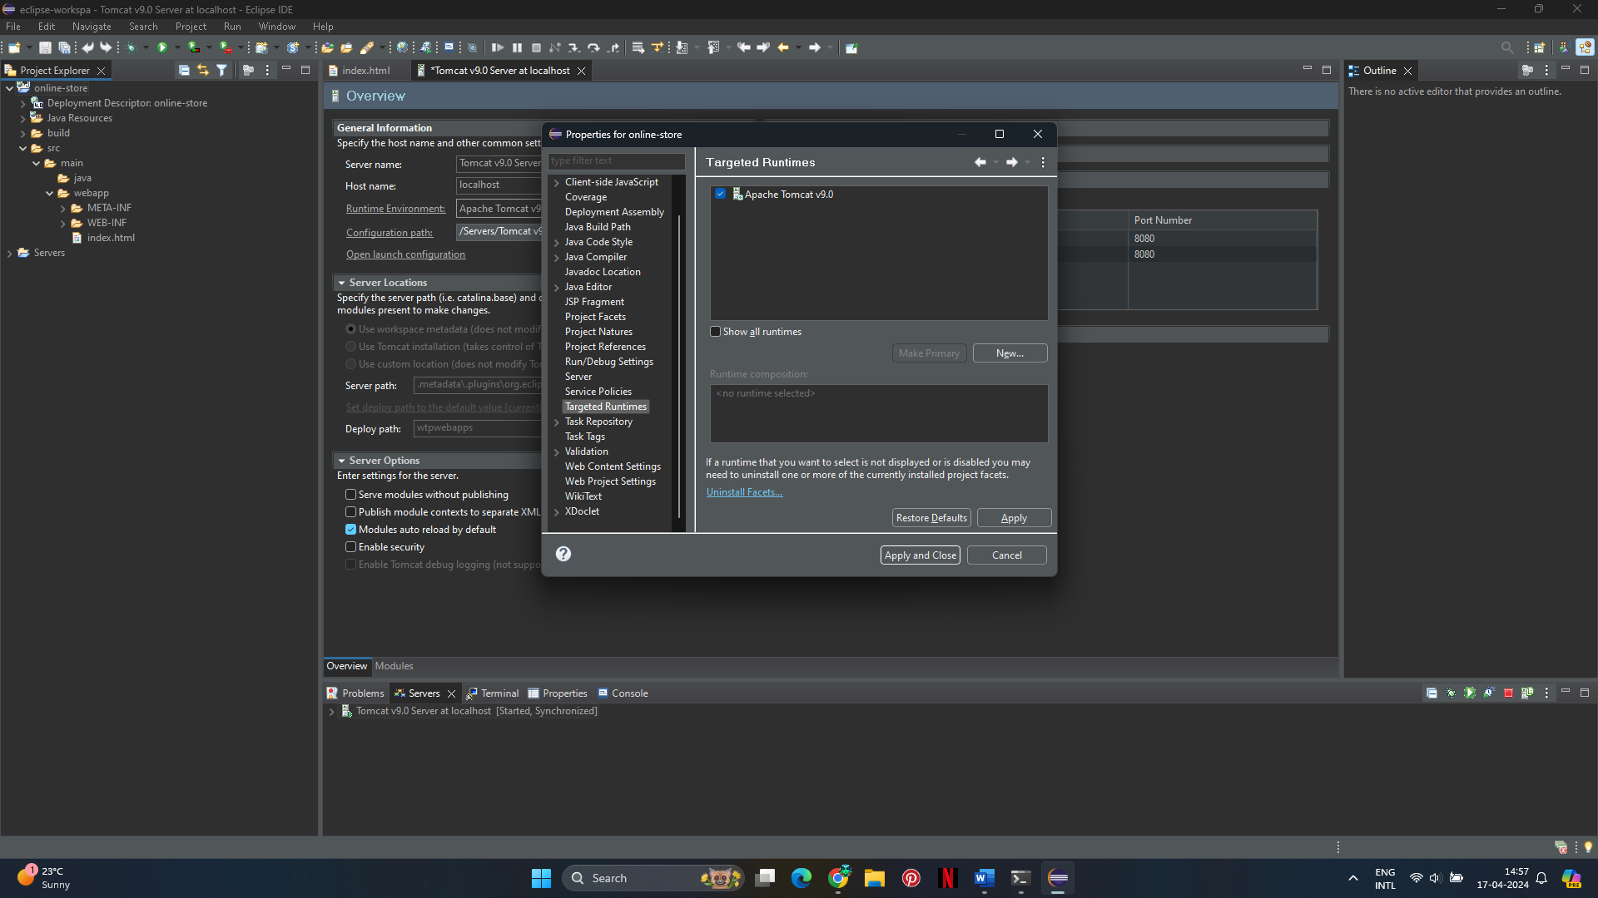

* + Right-click on your project again and select "Run As" > "Run on Server".
  + Choose "Tomcat 9" as the server and click "Finish".

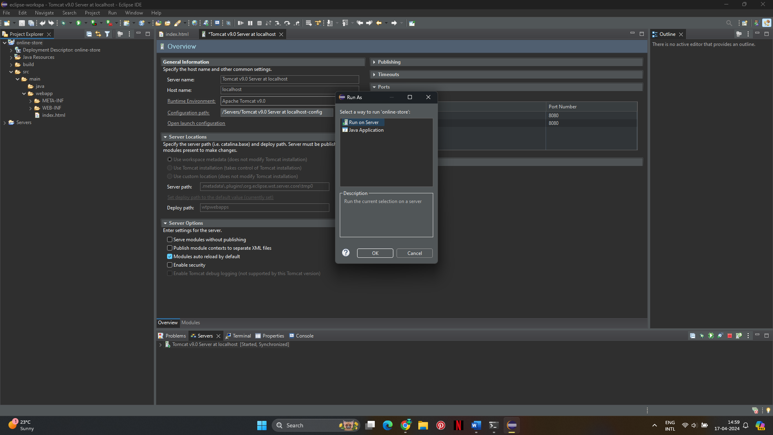

1. **Verify the Application is Up and Running:**
   * Open a web browser.
   * Navigate to http://localhost:8080/online-store/
   * Done

